## My*KNOW Recommended Learning set up and Issues

**What is my*KNOW?**

My*KNOW is a database that contains information about clients’ assessments, competencies and recommended learning. This training guide assumes that the reader have a good knowledge of my*KNOW and that you have administrator level access.

**What is recommended learning?**

Recommended learning points the my*KNOW customer to a further training guide, when they do not meet the standards required. For example this could be a failed assessment or e-learning module.

**How to set up recommended learning for an assessment**

* Create a recommended learning team in my*KNOW (for example 'Recommend Learning'.)
* Create a standard user login, both in my*KNOW and milestone. Assign the applicable assessment.
* Add your new user to your newly created recommended learning team.
* Add a recommended learning competency.
* Add a statement within that competency, e.g. 'complete topic successfully'.
* Edit the statement you have just created within your competency. In statement settings, add type 'Knowledge' and link the relevant topic. Add a tag to the statement, for example 'recommended learning'. This is the same tag that you will link to the media item, where the customer will be directed to and complete their additional training.

Example of editing a statement within a competency for recommended learning:-

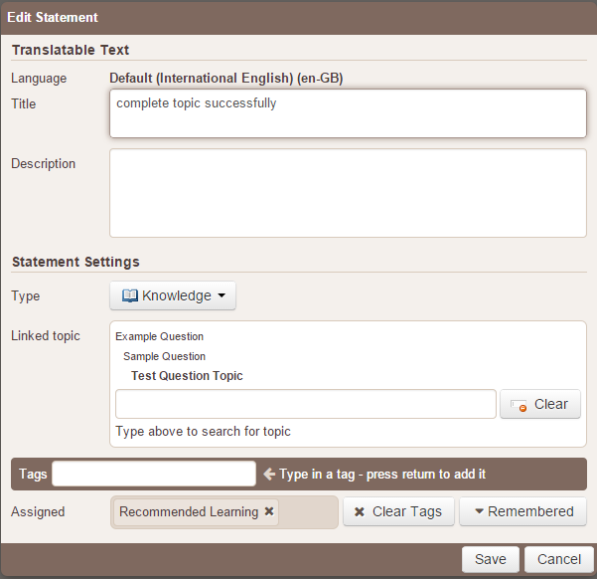

Continued/…

* Edit the event template within the competency you have just created. *Ensure you use the monitoring tab and not acquisition.* When you edit the event template, do the following:-
  + Give the Event Template a title 'E.g. Knowledge Test'
  + Add the 'Recommended Learning Competency' in the Competencies section
  + Choose Event Type – Knowledge Test
  + Search for the Linked Module, which will trigger the recommended learning, 'E.g. Sample Question. Note that the linked module list only lists the first 10 modules. If you cannot see your module, type it in the 'Linked Module' field and search for it.
  + The first occurrence should be set for 999 days.
  + Total Occurrences = 1

Example of setting up a recommended learning event template within a competency:-

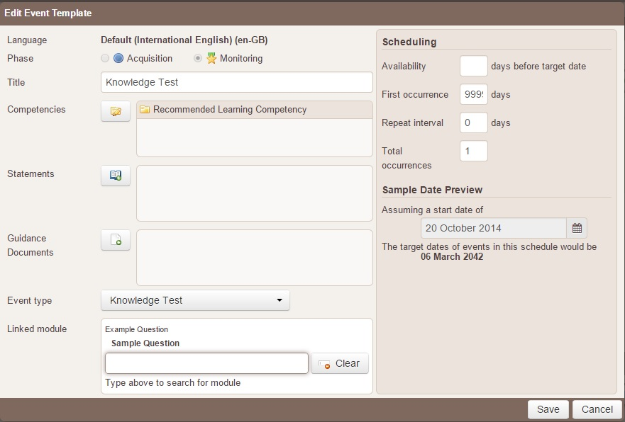

*What does First Occurrence mean?* - First occurrence means how long after the customer joins the team (i.e. their team join date in their profile), do you want the event to be available for? The answer is always as long as possible, because otherwise if a customer joins the team after the number of days in the first occurrence (set at 999 days), the customer will not get the event scheduled.

*What do Total Occurrences mean?* - This is the total number of events that you want to appear within the length your competency cycle. E.g. if the competency go live date is 1st January 2014 and the competency expiry is 100 years, only one event will appear within that 100 year period.

Continued/…

* Assign the competency to the recommended learning team you created. Within the settings ensure that:-
  + The competency 'go live date', which should be a date in the past.
  + The Acquisition start state should be – Automatically award (start in Monitoring)
  + The Monitoring start state should be – Competent
  + Within the monitoring phase, base dates on Individual award date and the validity period should be 100 years.

An example of editing the attributes when assigning a team competency:-

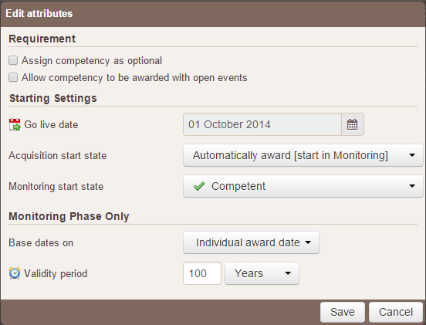

Continued/…

* Add your relevant training media in the 'media' section of my*KNOW, e.g. a link to a client training website or attach a training guide.
* Add your 'recommended learning' tag, which will link the media to the statement within your recommended learning competency.

An example of adding media linked to recommended learning:-

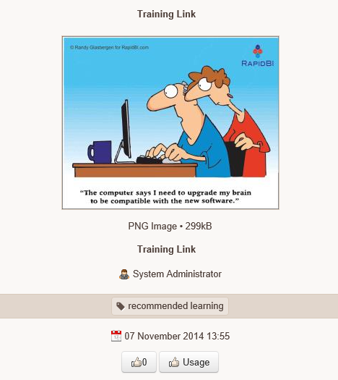

Continued/...

**Recommended Learning Issues**

* The customer’s event is not showing:-

If the customer joins the team after the target date of the event, the event won't show because my*KNOW will not think it is relevant for that customer, as they are out of the date range of the event template you set up.

Ensure that the first occurrence is set to 999. If it is left at the default of 0, the event will not be available to anyone in your team. (See above explanation of what 'first occurrence' means).

It is important to remember that the cycle of the event template will begin from the latest of three dates, i.e., the team join date, competency team go live date, or the customer’s award date. My*KNOW will look at the latest date and start the relevant competency event template cycle from then.

* Recommended learning has not appeared after the customer has not reached the standard:-

Check that you have added a statement tag in your statement within your competency. Also ensure that the same tag is in the media that you added and that both tags are spelt exactly the same.

If the customer is added to the team after they have completed their knowledge test, the recommended learning will not appear historically.